Article 8 — The Media Problem

Michal Doroszewski
You’re on a video call with a colleague who looks like he’s broadcasting from a submarine. His voice arrives in bursts, his face freezes mid‑sentence, and his background flickers between “office” and “digital purgatory.” You ask if he’s having network issues. He says no. You ask if he’s on Wi‑Fi. He says yes. You ask if he’s close to the router. He says, “Define close.”
Then your screen freezes.
You reconnect. He reconnects. The meeting resumes. Then it happens again. And again. Eventually, you both give up and switch to email, which feels like using carrier pigeons to discuss cloud architecture.
You haven’t changed. He hasn’t changed. The meeting hasn’t changed. The only thing that changed was the media system’s ability to maintain flow.
That is the Media Problem. Not the codec kind — the architectural kind. The kind that appears when real‑time media is routed through boundaries that distort timing, reshape packets, and hide instability. The kind that makes video calls behave like haunted mirrors and audio streams sound like Morse code.
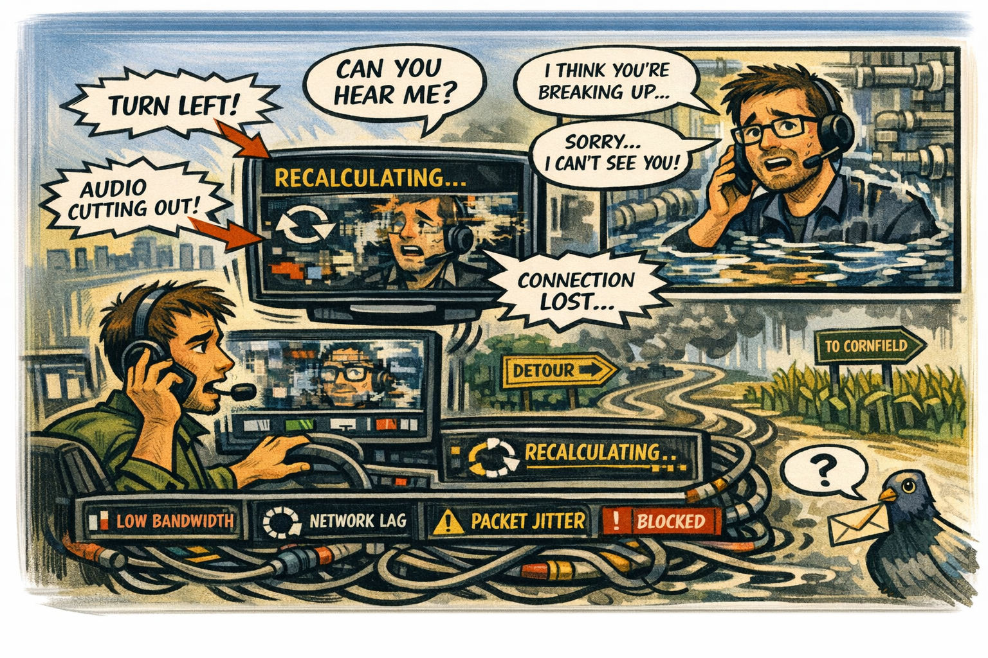

How Media Became the Litmus Test for Architecture
Media is unforgiving. It doesn’t wait. It doesn’t retry. It doesn’t tolerate delay. Real‑time media exposes architectural flaws instantly. If the path is unstable, the call breaks. If the region is wrong, the stream stutters. If the boundary reshapes packets, the codec fails. If telemetry is missing, the system cannot adapt.
Media doesn’t care about intentions. It cares about flow.

Why GCC‑Moderate Breaks Real‑Time Media
The FedRAMP Moderate boundary was designed for inspection, not flow. It introduces delay, reshapes packets, and reroutes traffic through hubs that were never intended to support real‑time media. The result is a system that behaves well in theory but collapses under the demands of live communication.
Media streams are routed through distant regions. Jitter increases. Packet loss goes undetected. Codec adaptation fails. Session continuity breaks. The system tries to recover, but the signals it needs are missing.
The architecture isn’t hostile. It’s incompatible.

Why Headquarters and Field Offices Experience Media Differently
Headquarters sits close to cloud egress and media controllers. Field offices sit behind WAN optimizers, MPLS circuits, and inspection layers. Headquarters sees stable media. Field offices see chaos.
Calls in headquarters are crisp. Calls in field offices are haunted. The same platform behaves differently depending on where the user sits. The architecture creates two realities — one smooth, one fragmented — and media reveals both instantly.

Why Media Failures Are Misdiagnosed
When media fails, teams look for culprits. Network blames bandwidth. Cloud blames configuration. Security blames policy. Users blame each other. Everyone is correct. Everyone is wrong.
The failure is architectural. The boundary reshapes packets in ways media cannot tolerate. The WAN introduces delay that codecs cannot adapt to. The telemetry is missing, so the system cannot diagnose the problem.
The system isn’t broken. It’s blindfolded and underwater.

Why Modernization Efforts Stall When Media Fails
Modernization depends on communication. When media fails, communication fails. Meetings become fragmented. Collaboration becomes asynchronous. Trust erodes. Teams revert to email. Leadership loses visibility. Decisions slow down.
This is not dysfunction. It is architectural misalignment. The system was designed for inspection. The workload is designed for flow.

The Root of the Media Problem
The media problem is not caused by bad codecs, poor configuration, or user error. It is caused by an architecture that predates real‑time communication.
The boundary reshapes packets.
The WAN introduces delay.
The telemetry is missing.
The region selection is distorted.
The adaptation logic is blind.
You cannot support real‑time media inside a system that hides instability.
You cannot troubleshoot calls without telemetry.
You cannot optimize flow without visibility.
You cannot modernize collaboration inside a maze.

The Only Way Forward
Media must be allowed to flow.
The boundary must support real‑time traffic.
Telemetry must be restored.
Region selection must reflect reality.
Packet reshaping must stop.
Codec adaptation must be informed.
Session continuity must be visible.
Only then can media behave the way it was designed to behave.
Only then can collaboration become real.
Only then can modernization stop feeling like a dropped call.

About the Author
Michal Doroszewski
Michal Doroszewski is a technology strategist focused on cloud architecture, identity platforms, and federal modernization. He writes about the structural and architectural forces that shape government IT, translating complex technical constraints into clear, accessible narratives for leaders and practitioners.

